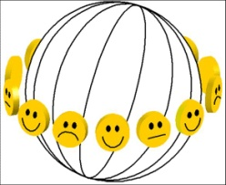 | Bibliography of Happiness  PUBLICATION NOTATION FORM | Id number

Author/ year:
O Pdf copy available
Discipline
O philosophy O social sciences O life sciences
Subject matter
O concept O measurement O determinants O consequences O beliefs and ideals
Type of document
O treatise O policy paper O literature study O general review O special subject
O report of empirical research O single study O meta-analysis O data set
Time frame of data on happiness
O past O present O expected O perceived changes in happiness
Happiness variants measured
O overall O hedonic level O contentment
Inclusion in findings archive
O yes: at least one valid measure of happiness used O no: no valid measure of happiness used O no: no new data
Subject categories addressed in this publication:
Identification number Short subject name

