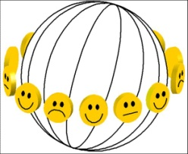 | Bibliography of Happiness  PUBLICATION NOTATION FORM | Id number

Author/ year:
O Pdf copy available
Discipline
O philosophy O social sciences O life sciences
Subject matter
O concept O measurement O determinants O consequences O beliefs and ideals
Type of document
O treatise empirical research literature review
O policy paper O single study O general review
O report of empirical research O meta analysis O special subject
O literature review O data set
Time frame of data on happiness
O past O present O future O perceived changes in happiness
Happiness variants measured
O overall O hedonic level O contentment
Inclusion in findings archive
O yes: at least one valid measure of happiness used O no: no valid measure of happiness used
Subject categories addressed in this publication:

